Term | Term 1 (Autumn 1) | Term 2 (Autumn 2) | Term 3 (Spring 1) | Term 4 (Spring 2) | Term 5 (Summer 1) | Term 6 (Summer 2)
Power Of Reading Text | 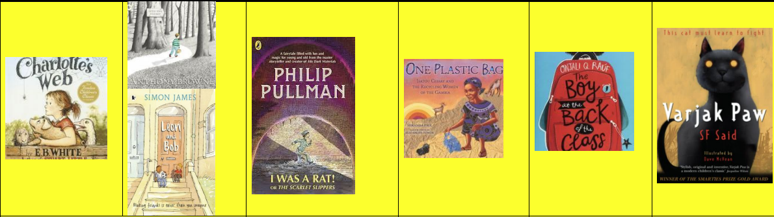 |  |  | 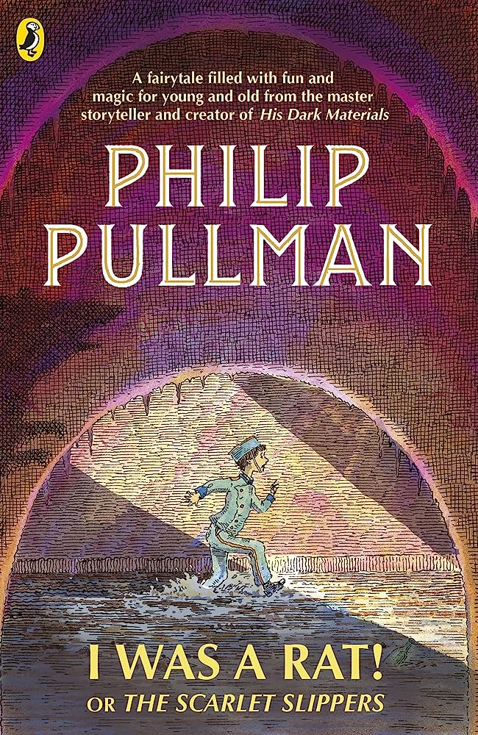 | 
Writing | Book Review on Charlotte’s Web.  *Plural and Possessive apostrophes *Expanded Noun Phrases *Fronted Adverbials *Paragraphs *Correct pronouns *Inverted Commas | Create a script for a chosen part of ‘Into the Forest’.  *Inverted commas *Correct Spellings *Pronouns *Plural and Possessive apostrophes *Range of punctuation | *Inverted commas *Correct Spellings *Pronouns *Plural and Possessive apostrophes *Range of punctuation *Determiners | Write a newspaper report  *Plural and Possessive apostrophes *Fronted Adverbials *Paragraphs *Correct pronouns *Inverted Commas *Writing for non-fiction purposes | Anti-Bullying School Policy.  *Correct Spellings *Pronouns *Plural and Possessive apostrophes *Range of punctuation *Determiners *Imperative verbs | Write a prediction text about the next Varjak Paw sequel.  *Correct Spellings *Pronouns *Plural and Possessive apostrophes *Range of punctuation *Determiners *Imperative verbs
Reading | Increase familiarity with a range of books Identify themes and conventions Prepare play scripts to read aloud Show understanding through intonation, tone, volume and action Discuss words and phrases that capture readers’ interest and imagination Draw inferences about characters’ feelings, thoughts, emotions and actions. | Identify themes and conventions Prepare play scripts to read aloud Show understanding through intonation, tone, volume and action Discuss words and phrases that capture readers’ interest and imagination Draw inferences about characters’ feelings, thoughts, emotions and actions. Read their own writing aloud to a group or the whole class, using appropriate intonation and controlling the tone and volume so that the meaning is clear | Develop positive attitudes to reading by listening to and discussing a wide range of fiction Increase familiarity with a range of books Identify themes and conventions Preparing poems and play scripts to read aloud and to perform Discuss words and phrases that capture readers’ interest and imagination | Maintain positive attitudes to reading and understanding of what they read by: Reading books that are structured in different ways and reading for a range of purposes Identifying and discussing themes and conventions in and across a wide range of writing Making comparisons within and across books Understand what they read by: Checking that the book makes sense to them, discussing their understanding and exploring the meaning of words in context Asking questions to improve their understanding | Increase familiarity with a range of books Identify themes and conventions and compare these across books they have read Discuss words and phrases that capture readers’ interest and imagination and consider how this impacts on the reader Draw inferences about characters’ feelings, thoughts, motives and actions, justifying inferences with evidence from the text Ask questions to improve their understanding identifying how language, structure and presentation contribute to meaning Predict what might happen from details stated and implied | Maintain positive attitudes to reading and understanding of what is read by: Continuing to read and discuss an increasingly wide range of fiction Reading books that are structured in different ways Increasing their familiarity with a wide range of books Identifying and discussing themes and conventions. Understand what they read by: Checking that the book makes sense to them, discussing their understanding and exploring the meaning of words in context Drawing inferences such as inferring characters’ feelings, thoughts and motives from their actions, and justifying inferences with evidence Predicting what might happen from details stated and implied Identifying how language, structure and presentation contribute to meaning Discuss and evaluate how authors use language, including figurative language, considering the impact on the reader Participate in discussions about books building on their own and others’ ideas.
Speaking and listening | Articulate and justify answers, arguments and opinions Use spoken language to develop understanding through imagining and exploring ideas in roleplay drama Select and use appropriate registers for effective communication. | Articulate and justify answers, arguments and opinions Use spoken language to develop understanding through imagining and exploring ideas in roleplay drama Select and use appropriate registers for effective communication | Maintain attention and participate actively in collaborative conversations, responding to comments Ask relevant questions to extend their understanding and build vocabulary and knowledge Listen and respond appropriately to adults and peers Articulate and justify answers and opinions Use spoken language to develop understanding through speculating, imagining and exploring ideas Participate in discussions, presentations, performances and debates | Listen and respond appropriately to adults and their peers Ask relevant questions to extend their understanding and knowledge Use relevant strategies to build their vocabulary Articulate and justify answers, arguments and opinions Give well-structured descriptions, explanations and narratives for different purposes, including for expressing feelings Maintain attention and participate actively in collaborative conversations, staying on topic and initiating and responding to comments | Maintain attention and participate actively in collaborative conversations, responding to texts Ask relevant questions to extend their understanding and build vocabulary and knowledge Articulate and justify answers and opinions Use spoken language to develop understanding through speculating, imagining and exploring ideas Participate in discussions, presentations, performances and debates | Use relevant strategies to build their vocabulary Articulate and justify answers, arguments and opinions Give well-structured descriptions and narratives for different purposes, including for expressing feelings Maintain attention and participate actively in collaborative conversations, staying on topic and initiating and responding to comments Use spoken language to develop understanding through speculating, hypothesizing, imagining and exploring ideas Participate in discussions, role play and debates Consider and evaluate different viewpoints, attending to and building on the contributions of others Select and use appropriate registers for effective communication.
Maths Summary | Number: Place Value Number: Addition and subtraction | Measurement: Area Number: Multiplication and division | Number: Multiplication and division Measurement: Length and Perimeter | Number: Fractions Number: Decimals | Number: Decimals Measurement: Money Measurement: Time  Statistics | Geometry: Properties of shapes Statistics Geometry: Position and direction
Science topic/ objectives | Animals including Humans  Teeth and the digestive system  a) describe the simple functions of the basic parts of the digestive system in humans  b) identify the different types of teeth in humans and their simple functions  c) construct and interpret a variety of food chains, identifying producers, predators and prey | Materials States of Matter and the Water Cycle  a) compare and group materials together, according to whether they are solids, liquids or gases  b) observe that some materials change state when they are heated or cooled, and measure or research the temperature at which this happens in degrees Celsius (°C)  c) identify the part played by evaporation and condensation in the water cycle and associate the rate of evaporation with temperature | Electricity  Circuits  Conductors and Insulators  a) identify common appliances that run on electricity  b) construct a simple series electrical circuit, identifying and naming its basic parts, including cells, wires, bulbs, switches and buzzers  c) identify whether or not a lamp will light in a simple series circuit, based on whether or not the lamp is part of a complete loop with a battery  d) recognise that a switch opens and closes a circuit and associate this with whether or not a lamp lights in a simple series circuit e) recognise some common conductors and insulators, and associate metals with being good conductors | Living Things and their Habitats  Classification Changing Habitats  a) recognise that living things can be grouped in a variety of ways  b) recognise that environments can change and that this can sometimes pose dangers to living things | Living Things and their Habitats (2)  Classification Habitats  a) explore and use classification keys to help group, identify and name a variety of living things in their local and wider environment | Sound  Vibrations  Volume Pitch Travel  a) identify how sounds are made, associating some of them with something vibrating  b) recognise that vibrations from sounds travel through a medium to the ear  c) find patterns between the pitch of a sound and features of the object that produced it  d) find patterns between the volume of a sound and the strength of the vibrations that produced it  e) recognise that sounds get fainter as the distance from the sound source increases
History |  | How did the Anglo-Saxons and Vikings change Britain?  A study of Anglo-Saxons and Vikings from 410 - 1066AD. Primary and Secondary resources |  |  | How did the Suffragettes change British Law?  A study of how Suffragettes changed the law. A local study of the suffragette movement in Bradford.
Geography | Rivers and The Water Cycle  Why are rivers important?  Features of a river  Erosion and Deposition  Identifying main UK rivers using a map  Rivers and Impact of flooding  River: Case Study What is the Amazon Basin used for? |  |  | Rivers and The Water Cycle  Why are rivers important?  Features of a river  Erosion and Deposition  Identifying main UK rivers using a map  Rivers and Impact of flooding  River: Case Study What is the Amazon Basin used for?
Art and design | Drawing Power prints Create several pencil tones when shading and create a simple 3D effect. Explore the effect of holding a pencil in different ways and applying different pressures. Use charcoal and rubber to show areas of light and dark in their drawings.  Demonstrate an awareness of the relative size of the objects they draw. Use scissors with care and purpose to cut out images. Try out multiple arrangements of cut images to decide on their composition. |  | Craft and design.  Fabric of nature Describe objects, images and sounds with relevant subject vocabulary. Create drawings that replicate a selected image. Select imagery and colours to create a mood board with a defined theme and colour palette. Complete four drawings, created with confident use of materials and tools to add colour. Understand the work of William Morris, using subject vocabulary to describe his work and style. |  | Painting & mixed media: Light and dark Try different arrangements of objects for a composition, explaining their decisions. Produce a clear sketch that reflects the arrangement of their objects.  Create a final painting that shows an understanding of how colour can be used to show light and dark, and therefore show three dimensions. Paint with care and control to make a still life with recognisable objects
DT | Food: Adapting a recipe |  | Textiles: Fastenings |  | Mechanical Systems: Making a slingshot car
Computing E Safety throughout | 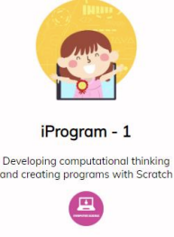 | 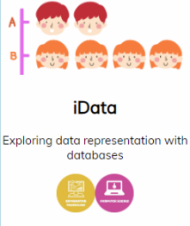 | 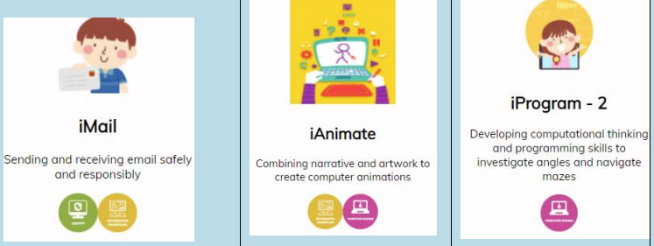 |  |  | 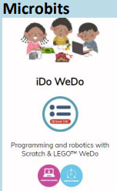
PSHE | Families and relationships Learning that families are varied and differences must be respected; understanding physical and emotional boundaries in friendships; exploring: the roles of bully, victim and bystander; how behaviour affects others; manners in different situations and learning about bereavement. | Health and wellbeing Developing emotional maturity; learning that we experience a range of emotions and are responsible for these; appreciating the emotions of others; developing a growth mindset; identifying calming and relaxing activities; developing independence in dental hygiene | Safety and the changing body This unit hub can be used to inform your medium term plan and to navigate to related resources | Citizenship This unit hub can be used to inform your medium term plan and to navigate to related resources. | Economic wellbeing  This unit hub can be used to inform your medium term plan and to navigate to related resources | PSHE Transition Lesson
Instrument: Recorders
Music | Body and tuned percussion (Theme: Rainforests) A topic of discovery; children will explore the rainforest through music and be introduced to new musical terms. They will also use a mixture of body percussion and tuned percussion instruments as the children create their own rhythms of the rainforest, layer by layer | Changes in pitch, tempo & dynamics (Theme: Rivers) Learning to listen to changes in pitch, tempo and dynamics and relate it to something tangible and familiar. Linking to their geography learning, the pupils represent different stages of the river through vocal and percussive ostinatos, culminating in a final group performance. | Recorders |  | Samba and carnival sound and instruments This unit hub can be used to inform your medium term plan and to navigate to related resources. | Adapting and transposing motifs (Theme: Romans) This unit hub can be used to inform your medium term plan and to navigate to related resources.
R.E | UC Creation 2a.1 What do Christians learn from the creation story? Digging Deeper | DS Sikhism L2.8 What does it mean to be a Sikh in Britain today? Digging Deeper | UC God L2.2 What is it Like to Follow God? Digging Deeper | DS Judaism 2.10 What does it mean for a Jewish person to follow God? Digging Deeper | UC Salvation L2.5 Why do Christians call the day Jesus died ‘Good’ Friday? Digging Deeper | DS Islam 1.8 Who am I? What does it mean to belong? Digging Deeper
P.E | Hockey Dodgeball | Athletics Tennis | Gymnastics Swimming | Cricket Swimming | Dance Swimming | Orienteering Swimming
Visits | Visits/ Visitors: Residential Trip Nell Bank | Visits/ Visitors: Jorvik and The Dig Visit Place of Worship: Gurdwara | Visits/ Visitors: Drama Visit | Visits/ Visitors: Bolton Abbey Rivers Trip | Visits/ Visitors: | Visits/ Visitors: Suffragette Visit – Emmeline Pankhurst Society

