Good Morning!
Well, who would have thought we’d still be at home? I hope that everyone is keeping safe and warm. Today someone from school will be ringing your family to see how you are all doing, that someone maybe me; it will most definitely be someone from our class or an adult from a brother or a sister’s class.
Today’s activities:
- Money
I can make 4p three different ways:
Please note that we don’t have 3p, 4p, 6p coins!

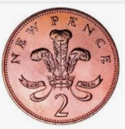

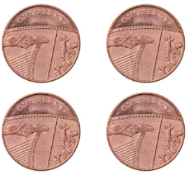
- How many different ways could you make 5p (remember you can you use a 5p coin)?
- How many different ways could you make 6p (remember you can you use a 5p coin)?
Could you keep going by making all the different ways for 7p, 8p, 9p and 10p

- Here’s my poem about summer, imagine being on the beach or at the playground when it is warm – that’s quite difficult now.

Swimming
Splashing
Squirting
Laughing
Paddling
Digging
Swinging
Stretching
Sleeping

Each word is a verb and ends with ing, I would like you to do something similar but for winter.

- Yesterday I had to walk to the shop and it was dangerous. I couldn’t walk on the path because it was covered in deep snow and the road was slippy and dangerous with cars coming towards me in both directions. There are so many ways that we have to protect ourselves in winter, could you write a list of ways that we protect ourselves from the cold and the ice and the snow.

Please continue to read and to challenge yourself on TT Rockstars.

Keep Safe

Mrs Sykes and Eric

