Snow (and ice day) 8.1.25
Good Morning! I hope that you’re all keeping warm and safe.
Today’s Activities.
- In this term’s maths topic we are learning about money. Ask an adult to show you the coins that we use. Could you place them in size order, look at them carefully and draw them in their size order.
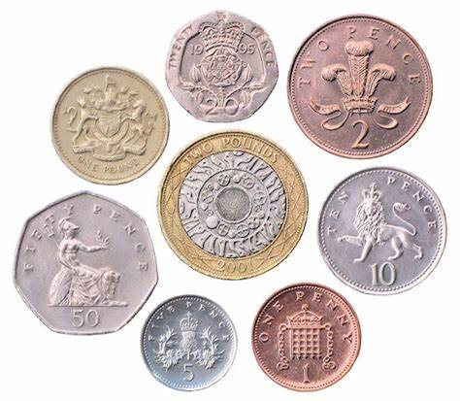

- Science. Do you remember when we classified items into:
Alive
Once alive
Never been alive
Could you find items round your home and group them into the above groups and draw them.

- TT Rock Stars

- Watch a cartoon or an animation, then retell the story to a family member.

